Planning Proposal
To amend the zoning of land under State Environmental Planning Policy (Sydney Region Growth Centres) 2006 – Lots 2701-2705 in DP 1230905 and Lot 2577 in DP1223745, Chambers Street, Marsden Park

December 2020
Part 1 – Objectives or intended outcomes 3
1.1 Introduction 3
1.2 Applicable land 5
1.3 Current planning controls 6
Part 2 – Explanation of provisions 9
2.1 Amendments to State Environmental Planning Policy (Sydney Region Growth Centres) 2006 (Growth Centres SEPP) 9
2.2 Mapping amendments 10
Part 3 – Justification 12
3.1 Section A – Need for the Planning Proposal 12
3.2 Section B – Relationship to strategic planning framework 12
3.3 Section C – Environmental, Social and Economic Impacts 15
3.4 Section D – State and Commonwealth interests 16
Part 4 – Mapping 16
Part 5 – Community consultation 16
Part 6 – Timeline 17
Attachments
Attachment 1: Consistency with Greater Sydney Region Plan, Central City Plan, Blacktown Community Strategic Plan and Blacktown LSPS
Attachment 2: Consistency with Applicable SEPPs and REPs
Attachment 3: Consistency with Relevant Section 9.1 Directions by the Minister

Part 1 – Objectives or intended outcomes

Introduction
Blacktown City Council has received a request from GLN Planning on behalf of Stockland Development Pty Ltd (Stockland) to amend State Environmental Planning Policy (Sydney Region Growth Centres) 2006 (the Growth Centres SEPP). The Planning Proposal applies to Lots 2701-2705 in DP1230905 and Lot 2577 in DP1223745, Chambers Street, Marsden Park.

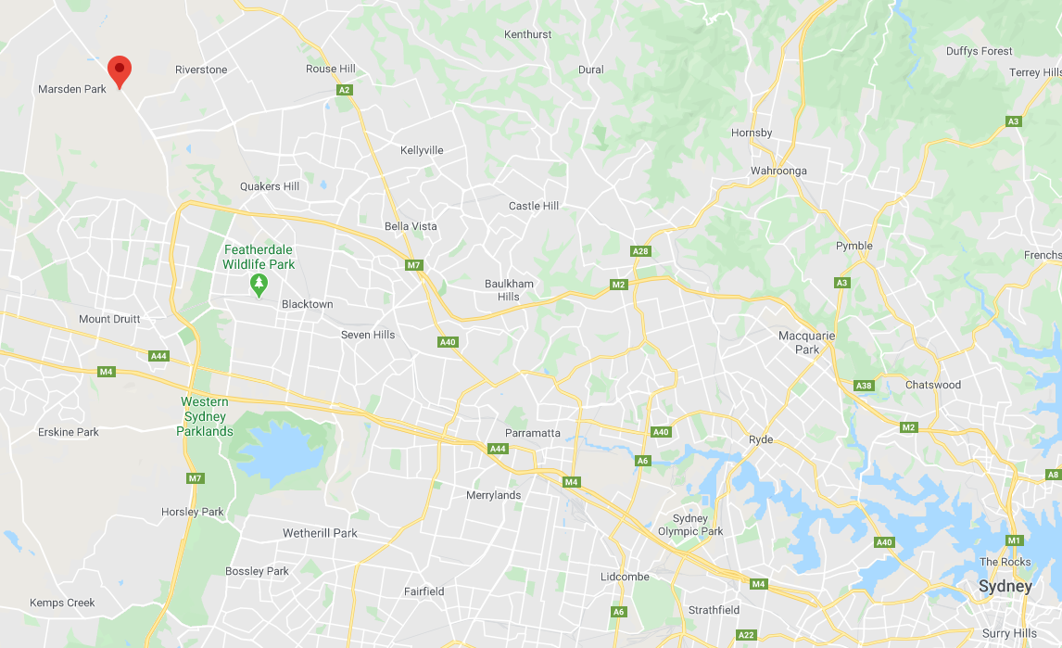
Figure 1: Regional Context Map
Chambers Street, Marsden Park

The subject site is located in the Marsden Park Precinct in the North West Growth Area (NWGA). The Marsden Park Precinct is located approximately 40km from the Sydney CBD, 10km from Blacktown and 9.21km from Rouse Hill Town Centre. The Marsden Park Indicative Layout Plan (ILP) is shown in Figure 2, with the subject site outlined in red.
The subject site is located in the ‘Elara’ Estate on the western side of Richmond Road, to the North of Elara Boulevard and to the South of Blackstone Street as shown in Figure 3.
On the site, the seven lots are zoned partly R2 Low Density Residential and partly SP2 Infrastructure (Local Drainage) as a result of approved and registered subdivision plans DA-16-05045 and DA-15-02897.

Figure 2: Marsden Park Precinct Indicative Layout Plan
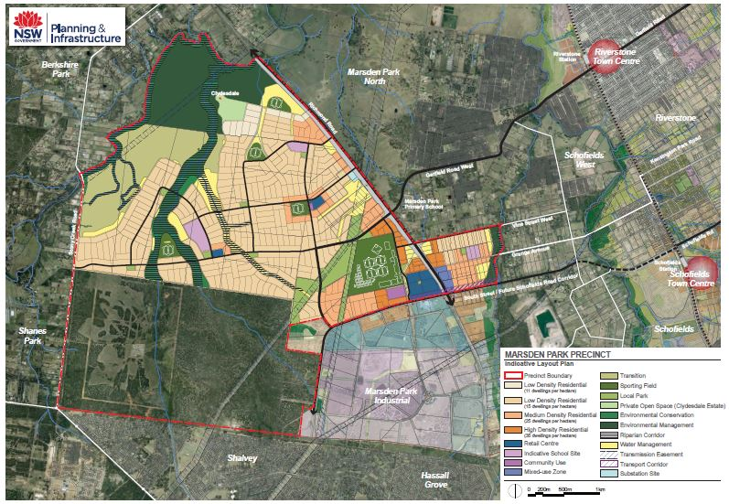
Subject Site

Figure 3: Aerial view of the site 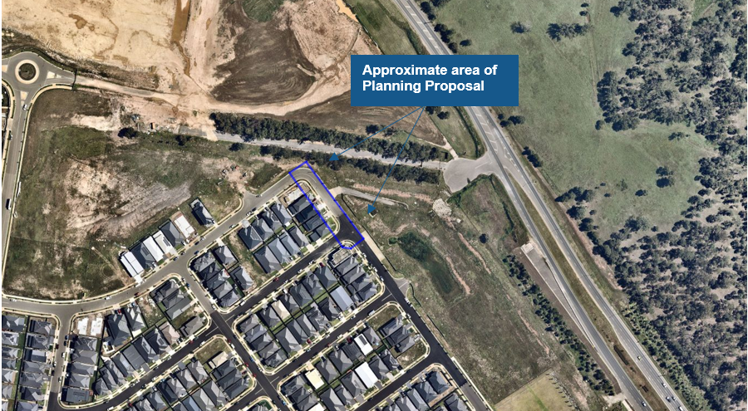 The objective of this Planning Proposal is to rezone land by adjusting the boundary between the R2 Low Density Residential zone and the SP2 Infrastructure (Local Drainage) zone so that it is consistent with the registered lot boundaries.
The proposal will necessitate amendments to the Land Zoning, Height of Buildings, Residential Density and Land Reservation Acquisition Maps (Sheet 005) under the Growth Centres SEPP.
The intended outcomes of this Planning Proposal are to:
- facilitate the amendment of the Growth Centres SEPP so that the subject lots can be wholly zoned R2 Low Density Residential
- provide consistency of zones with the approved subdivision plans
- apply the associated height of building and residential density planning controls with the rezoned R2 Low Density Residential land
- remove council as the acquisition authority from the SP2 Infrastructure (Local Drainage) zone area on the residential lots.

Applicable land
The Planning Proposal applies to land in the Marsden Park Precinct which forms part of the NWGA. Future development on the site and surroundings is shown in the ILP within the Blacktown City Council Growth Centres Precincts Development Control Plan Schedule 6 (Marsden Park Precinct).
The applicable land subject to the Planning Proposal is shown in Figure 4 and outlined in Table 1 below.
Figure 4: Site location relative to previous DA site boundaries
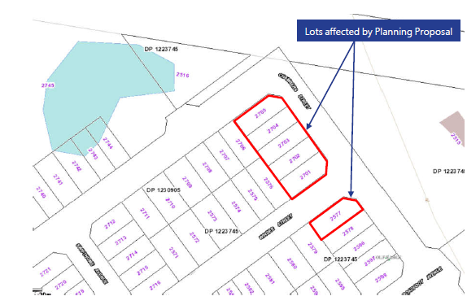

Table 1: Description of lots subject to planning proposal (Subject Site)
Lot | DP | Address
2701 | 1230905 | 33 Chambers Street, Marsden Park
2702 | 1230905 | 35 Chambers Street, Marsden Park
2703 | 1230905 | 37 Chambers Street, Marsden Park
2704 | 1230905 | 39 Chambers Street, Marsden Park
2705 | 1230905 | 41 Chambers Street, Marsden Park
2577 | 1223745 | 31 Chambers Street, Marsden Park

Current planning controls
Under the Growth Centres SEPP, the site is currently zoned part R2 Low Density Residential and part SP2 Infrastructure (Local Drainage).
On the land zoned R2 Low Density Residential, the following provisions are relevant to this Planning Proposal:
- Height of Buildings. Under this clause, the R2 Low Density Residential portion of the site is identified as having a maximum building height of 9m
- Residential Density. This clause applies a minimum residential density of 15 dwellings per hectare over the area of the site which is zoned R2 Low Density Residential
- Relevant acquisition authority. The area of the site zoned SP2 Infrastructure (Local Drainage) has been identified for future acquisition on the Land Reservation Acquisition Map.
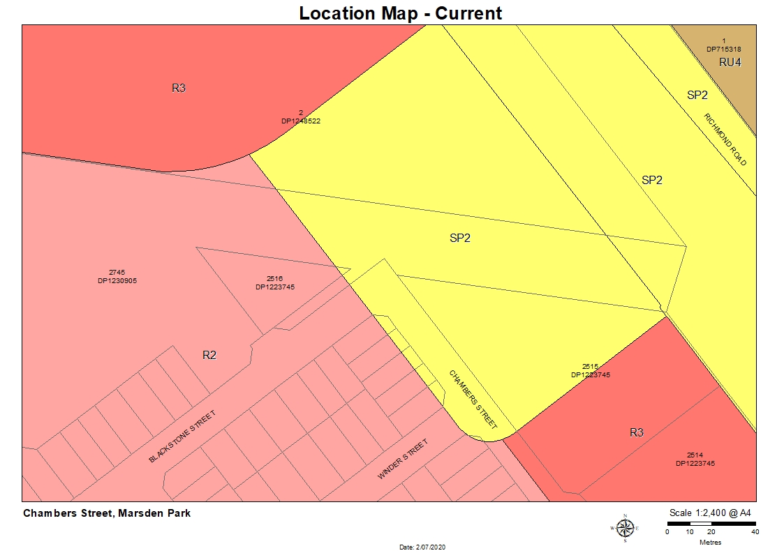
Figure 5: Existing Land Zoning Map
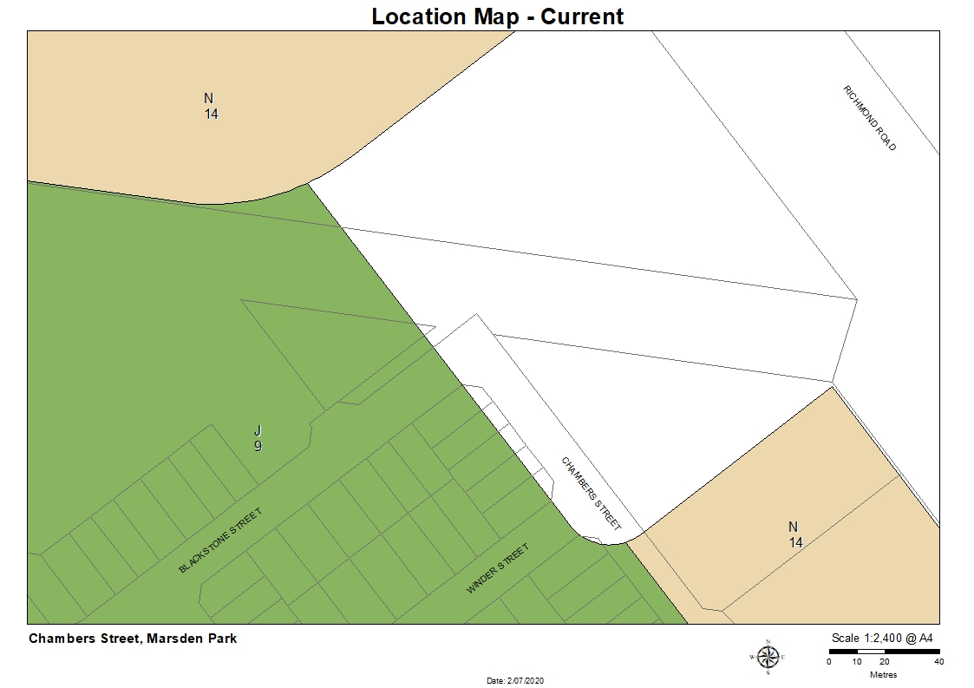
Figure 6: Existing Height of Buildings Map
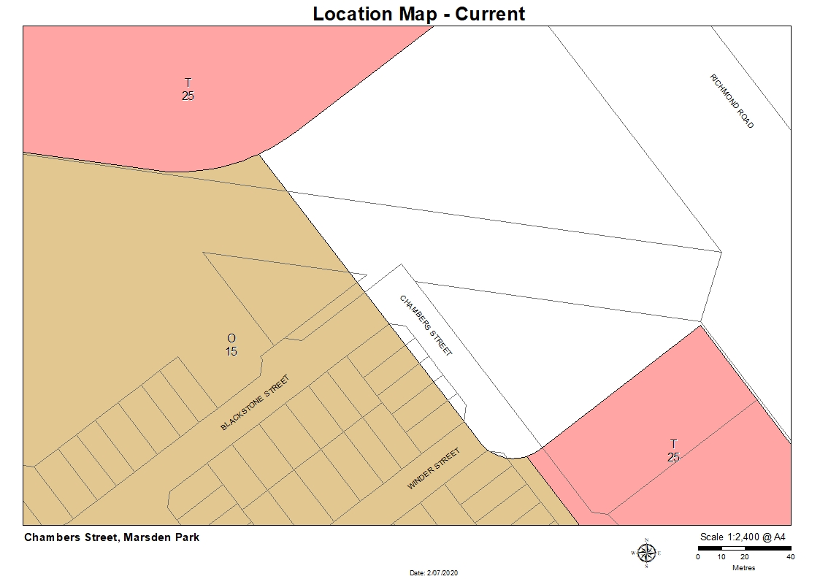
Figure 7: Existing Residential Density Map
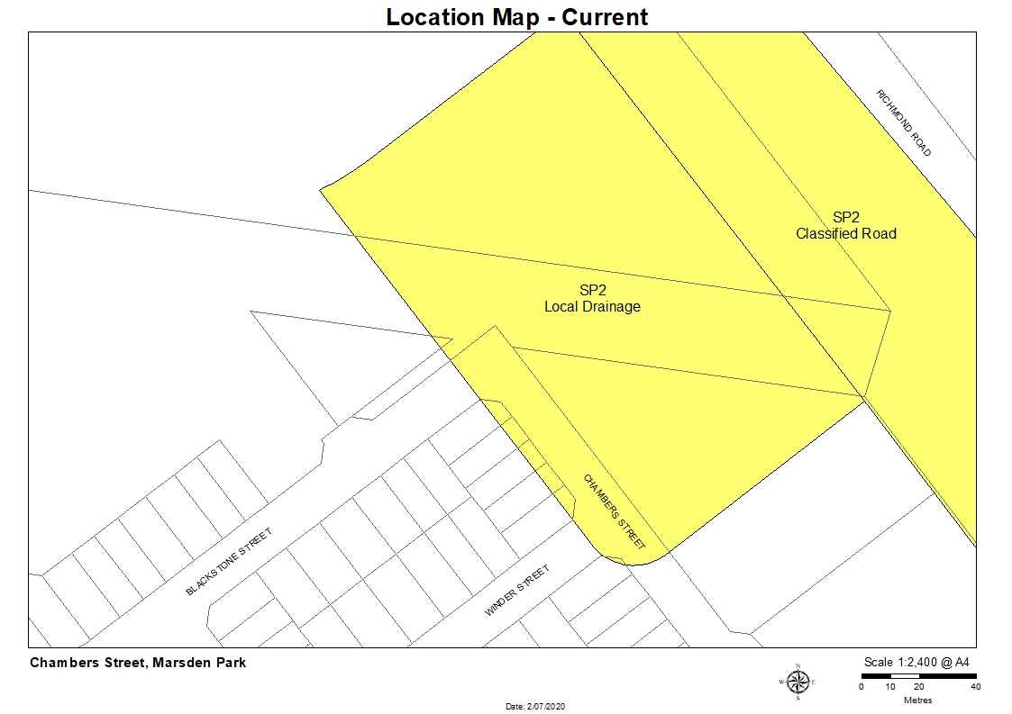
Figure 8: Existing Land Reservation Acquisition Map

Part 2 – Explanation of provisions

Amendments to State Environmental Planning Policy (Sydney Region Growth Centres) 2006 (Growth Centres SEPP)

This Planning Proposal seeks to amend the land zoning, height of buildings, residential density and land acquisition controls which apply to the site, located within the Marsden Park Precinct. To achieve the objectives and intended outcomes of the Planning Proposal, such amendments to the Growth Centres SEPP are required to reflect the approved subdivision plans. No associated changes are required to other provisions of the Blacktown City Council Growth Centre Precincts DCP Schedule 6 (Marsden Park Precinct).
The objectives and intended outcomes can be achieved by amendments to the NWGA maps under the Growth Centres SEPP as follows:
- Amend the Land Zoning Map
  - Amend the Land Zoning Map (Sheet LNZ_005) to align to R2 and SP2 Infrastructure (Local Drainage) land use zones with the approved plans by rezoning the subject lots and road to R2 Low Density Residential to align with adjoining zone. The location of the drainage basin is proposed to be adjusted eastward around the bend of Chambers Street.

- Amend the Height of Building Map
  - Amend the Height of Building Map (Sheet HOB_005) to apply a maximum height of buildings control of 9 metres over the rezoned area. The proposed height control is consistent with the adjoining R2 Low Density Residential zone.

- Amend the Land Reservation Acquisition Map
  - Amend the Land Reservation Acquisition Map (Sheet LRA_005) to remove Council as the acquisition authority over the rezoned portion of each residential lot and road. The proposal seeks to align land identified to be acquired with the SP2 Infrastructure (Local Drainage) zoning.

- Amend the Residential Density Map
  - Amend the Residential Density Map (RDN_005) to apply a residential density control of 15 dwellings per hectare for the adjusted location of the R2 Low Density Residential zone.

Mapping amendments
Maps showing the existing and proposed changes to Land Zoning, Height of Buildings, Residential Density and Land Reservation Acquisition maps are shown in Figures 9-12.

Figure 9: Land Zoning Map
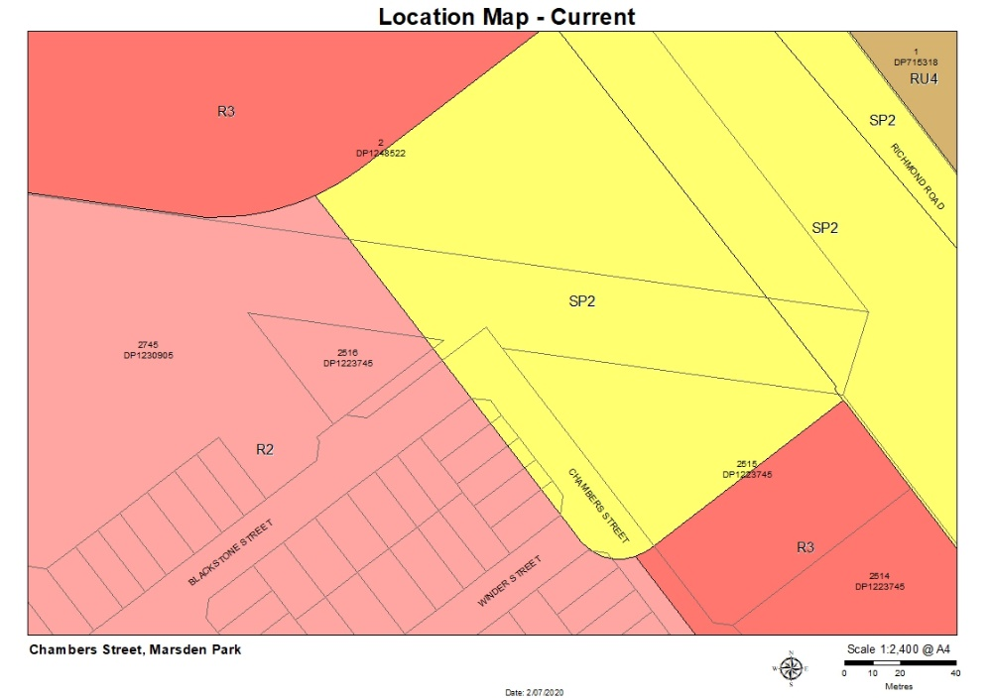
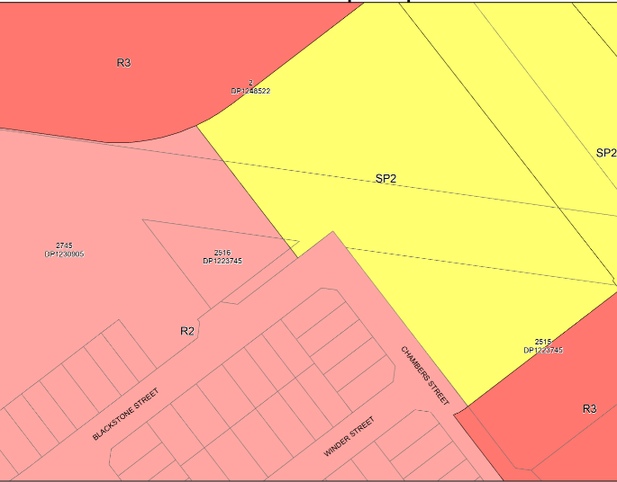
PROPOSED
EXISTING

Figure 10: Height of Buildings Map
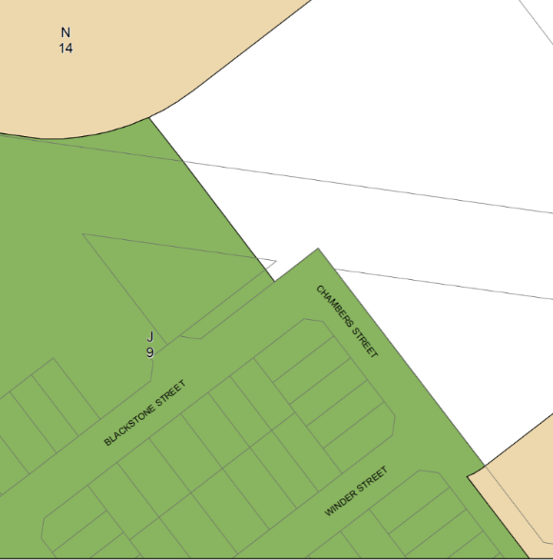
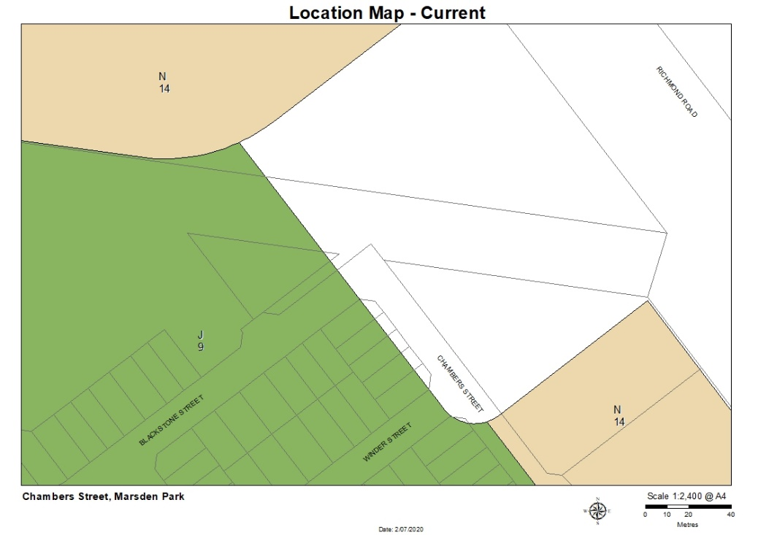
EXISTING
PROPOSED

PROPOSED

Figure 11: Residential Density Map
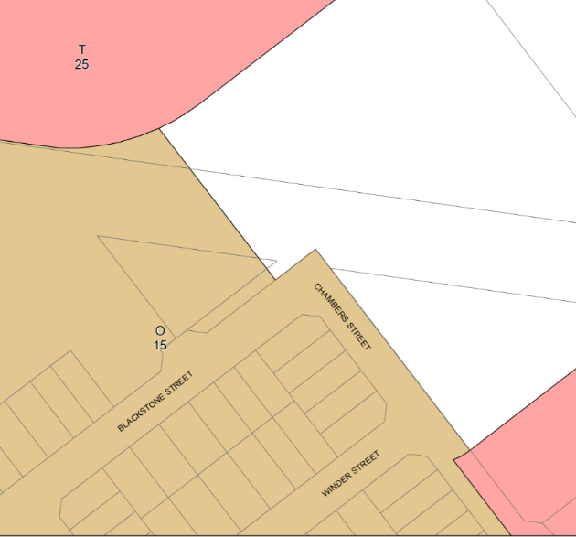
EXISTING
PROPOSED

Figure 12: Land Reservation Acquisition
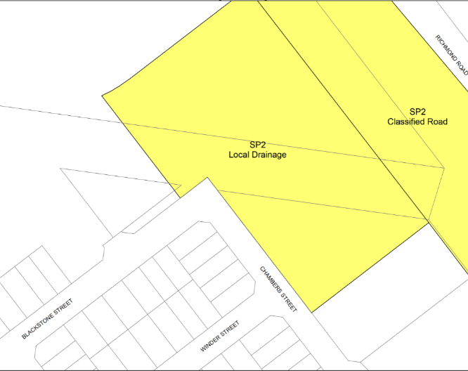
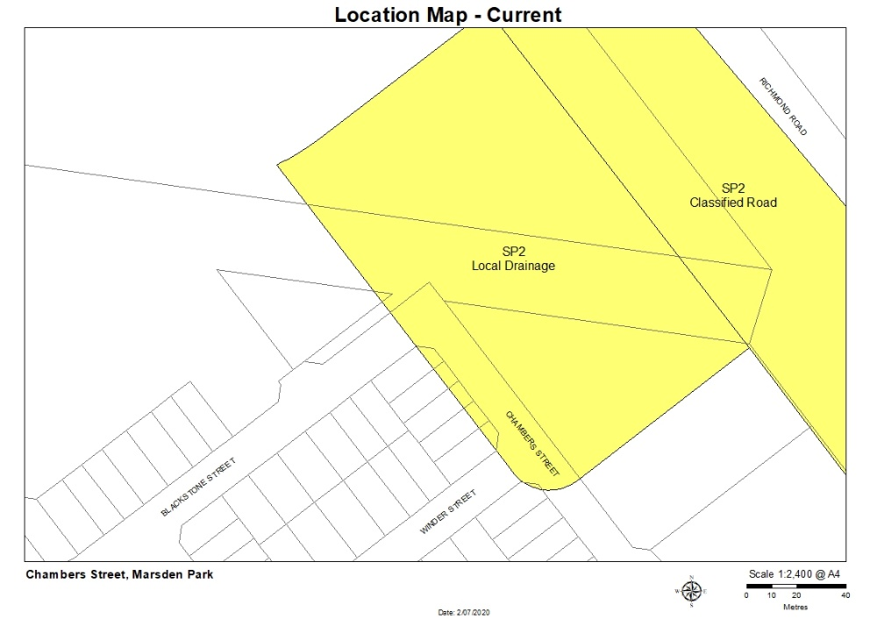
PROPOSED
EXISTING

Part 3 – Justification

Section A – Need for the Planning Proposal
- Is the Planning Proposal a result of any strategic study or report?
No. The Planning Proposal is not a result of any strategic study or report.
This Planning Proposal was initiated as a result of an inconsistency of land use zoning boundaries identified from the approved and registered subdivision plans (DA-16-05045 and DA-15-02897). As the seven affected lots are not wholly zoned residential, the proposal seeks to align the R2 Low Density Residential and SP2 Infrastructure (Local Drainage) with the registered lots. Consistency with the strategic planning framework is established in Section B of this Planning Proposal.
- Is the Planning Proposal the best means of achieving the objectives or intended outcomes, or is there a better way?
Yes. A Planning Proposal is the best means of achieving the objectives and intended outcomes. Amendments to the Growth Centres SEPP Maps can only be achieved via the LEP Planning Proposal process.
Amendment to the Land Zoning Map to rezone to SP2 Infrastructure (Local Drainage) to R2 Low Density Residential and readjust the drainage basin is the best means to achieve the objective of realign boundary zones that impact portions of various lots.
Amendment to the Height of Buildings Map by applying a 9 m height control, Residential Density Map by applying a 15 dwelling density control and land reservation acquisition by removing Council as the acquisition authority is the best means in achieving the objectives. Amending these controls are necessary for consistency with the R2 Low Density Residential zoning as approved in the subdivision plan and ensures future development can occur in an appropriate and certain manner.

Section B – Relationship to strategic planning framework
- Is the Planning Proposal consistent with the objectives and actions contained within the applicable regional or district plan or strategy (including the Greater Sydney Region Plan)?
- Greater Sydney Region Plan
The Planning Proposal is not inconsistent with the aims and actions contained within The Greater Sydney Region Plan, A Metropolis of three Cities (Region Plan). The Region Plan sets a 40-year vision and strategy for Greater Sydney, to be implemented at a local level through District Plans. Attachment 1 describes how the proposal is consistent with the objectives of the Region Plan.
- Central City District Plan
The Central City District Plan aligns with the Greater Sydney Region Plan and provides a 20-year framework to manage growth and achieve the plans long term vision, while enhancing Greater Sydney’s liveability, productivity and sustainability into the future. It is a guide for implementing the Greater Sydney Region Plan at a District level and a bridge between regional and local planning. The Marsden Park Precinct, which includes the subject site, is located within the Central City District.
Consistency with the themes, priorities and actions of the Central City District Plan are discussed in Attachment 1. This analysis shows that the Planning Proposal is not inconsistent with the objectives of the Central City District Plan.
- Marsden Park Precinct Plan
The Marsden Park Precinct Plan was published on October 2013. Along with planning provisions within the Growth Centres SEPP, detailed controls for the Precinct are found within the Blacktown Growth Centres Precincts DCP. The ILP is contained within the DCP, which sets the broad parameters and overarching vision for Precinct. Specifically, new development within the Precinct needs to be generally in accordance with the indicative location and hierarchy of roads, housing densities, infrastructure, open space and community facilities and services, as shown on the ILP.
The Planning Proposal is considered to achieve what is anticipated under the ILP. These proposed amendments to land use, height, density and acquisition will create consistency and practicality of land use.
- Is the Planning Proposal consistent with Council’s local strategy or other local strategic plan?
- Blacktown Local Strategic Planning Statement 2020 (LSPS)
On 25 March 2020, Council adopted the Blacktown Local Strategic Planning Statement 2020 (LSPS) which establishes how future growth and change will be managed throughout the City. Specifically, the LSPS:
- sets a 20-year land use vision and structure plan for the entire local government area
- identifies the characteristics that make the Blacktown City community unique
- directs how future growth and change will be managed across the local government area
- informs changes to the Blacktown Local Environmental Plan 2015 and Development Control Plan 2015 and to other plans that affect our City
- identifies where further detailed strategic planning may be needed.
To achieve these above objectives, the LSPS includes priorities and actions to support the vision for our City and to guide development, balancing the need for housing, jobs and services with the natural environment. The Planning Proposal ensures that the site will be developed in line with the LSPS which is consistent with housing supply within the NWGA. Consistency of the Planning Proposal with the LSPS is detailed in Attachment 1.
- Our Blacktown 2036 - Community Strategic Plan (CSP)
Our Blacktown 2036 identifies the main priorities of the local community and aspirations for the City to 2036. Its directions and objectives are based on principles of sustainability and social equity and includes transformational projects to ensure the vision is delivered. The Planning Proposal remains consistent with the strategic directions of Our Blacktown 2036.

Consistency of the Planning Proposal with the Community Strategic Plan is detailed in Attachment 1.

- Land Use Infrastructure Implementation Plan (LUIIP)

The proposed amendment to the Growth Centres SEPP will rezone land from SP2 Infrastructure (Local Drainage) to R2 Low Density Residential over part of the site in the Marsden Park Precinct of the NWGA. The height of buildings, residential density and land reservation acquisition maps are proposed to be consistent with the adjoining land.

The Planning Proposal does not propose to change any other requirements of the Growth Centres SEPP and associated DCP and is seeking to create consistency of land use zones with the approved subdivision plans. It therefore remains consistent with the principles of the LUIIP.

- Is the Planning Proposal consistent with applicable State Environmental Planning Policies?
The Planning Proposal is consistent with the applicable SEPPs. A review of the proposals consistency with the relevant SEPPs is detailed in Attachment 2.

- Is the Planning Proposal consistent with applicable Ministerial Directions (s.9.1 Directions by the Minister)?
The Planning Proposal is consistent with the applicable Ministerial Directions as shown in Attachment 3.

Section C – Environmental, Social and Economic Impacts
- Is there any likelihood that critical habitat or threatened species, populations or ecological communities, or their habitats, will be adversely affected as a result of the proposal?
No. Critical habitats, threatened species, population, ecological communities or their habitats will not be adversely affected as a result of the proposal.
The site is biodiversity certified and has been cleared under approved bulk earthworks DAs.
- Are there any other likely environmental effects as a result of the Planning Proposal and how are they proposed to be managed?
No. The Planning Proposal is not expected to have any adverse environmental impacts as the rezoning is considered to be a minor adjustment of the zone boundaries. Relevant environmental impacts were assessed as part of the previously approved bulk earthworks and subdivision applications on the site.
- How has the Planning Proposal adequately addressed any social and economic effects?
The Planning Proposal relates to land located in the Marsden Park Precinct under the Growth Centres SEPP. The proposed changes will align and create zones that are wholly R2 Low Density Residential and wholly SP2 Infrastructure (Local Drainage). This will provide consistency and avoid any negative and social economic impacts or confusion that would result from impractical zone boundaries.

Section D – State and Commonwealth interests
- Is there adequate public infrastructure for the Planning Proposal?
Yes. The Planning Proposal does not increase residential yield or demand for additional local infrastructure but seeks to realign zone boundaries with approved development applications.
- What are the views of State and Commonwealth public authorities consulted in accordance with the Gateway determination?
Consultation with relevant Commonwealth and State public authorities will be undertaken as directed by the Gateway determination.

Part 4 – Mapping
The Planning Proposal is accompanied by the following SEPP Maps at Appendix A:
- Existing Land Zoning Map
- Proposed Land Zoning Map
- Existing Height of Buildings Maps
- Proposed Height of Buildings Map
- Existing Residential Density Map
- Proposed Residential Density Map
- Existing Land Reservation Acquisition Map
- Proposed Land Reservation Acquisition Map

Part 5 – Community consultation
The Gateway determination will stipulate the nature and extent of required community consultation in accordance with the document ‘A guide to preparing local environmental plans’.
Public consultation will take place in accordance with the Gateway Determination and as required under the Environmental Planning and Assessment Act 1979.

Part 6 – Timeline
Stage | Estimated Date
Resolution to prepare | December 2020
Gateway Determination | February 2021
Public exhibition | March 2021
Consider submissions | April 2021
Council resolution to adopt | June 2021
Forward Planning Proposal to Department of Planning, Industry and Environment to request that the plan be made | June 2021

